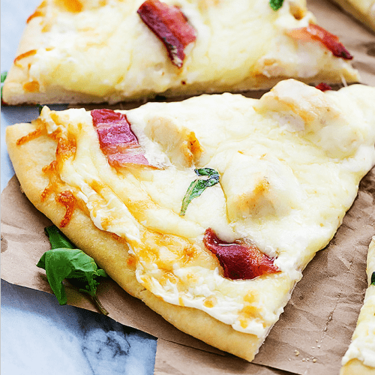
Bacon Chicken Alfredo Pizza
Prep time 20 min Cook time 30 min
4 Servings
Ingredients
1 boneless skinless chicken breast
one prepared pizza dough
4 tablespoons butter divided
½ teaspoon Italian seasoning
1 tablespoon flour
1 cup heavy whipping cream
¼ teaspoon salt or to taste
¼ teaspoon black pepper
2 teaspoon garlic minced
½ cup grated parmesan cheese
2 cups shredded mozzarella cheese
4 strips bacon cooked
chopped fresh basil (optional)
½ cup red onion thinly sliced (optional)
Directions
- Heat oven to 400 degrees for dark or nonstick pan (425 degrees for all other pans). Spray 15x10x1 inch pan with cooking spray.
- Unroll dough in pan. Starting at center, press dough into 15x10 inch rectangle. Brush with 2 tablespoons melted butter. Sprinkle Italian seasoning on top.
- Grease a large skillet and season chicken with salt and pepper on both sides. Cook in greased skillet over medium heat for 5 to 6 minutes on each side until cooked through. Cut into ½ inch cubes or shred and set aside.
- For Pillsbury Classic Crust pizza dough, bake for 8 minutes.
- In the skillet where you cooked the chicken, melt remaining 2 tablespoons butter over medium heat. Stir in flour until mixture comes together. Gradually whisk in heavy whipping cream over medium heat until bubbly. Stir in salt, pepper, garlic, and parmesan cheese.
- Stir chicken into sauce.
- Spread sauce over the partially baked crust and top with red onion. Then sprinkle with mozzarella cheese. Rotate pan 180 degrees and bake for 7 minutes until cheese is melty. Top with bacon and basil. Serve immediately.

